**LAB 03**

**Startup #01**

#include <iostream>

using namespace std;

main(){

bool trueValue,falseValue;

int x=5,y=10;

trueValue=x<y;

falseValue=x>y;

cout<<"True is "<<trueValue<<endl;

cout<<"False is "<<falseValue;

}

**CONCLUSION:**

//True means 1 and false means 0 so if our condtion is true then program can print 1

//If condition is false then progarm can compile 0

//In this case condition is true so program compile 1 from where condition is true

//and compile 0 from where condition is false

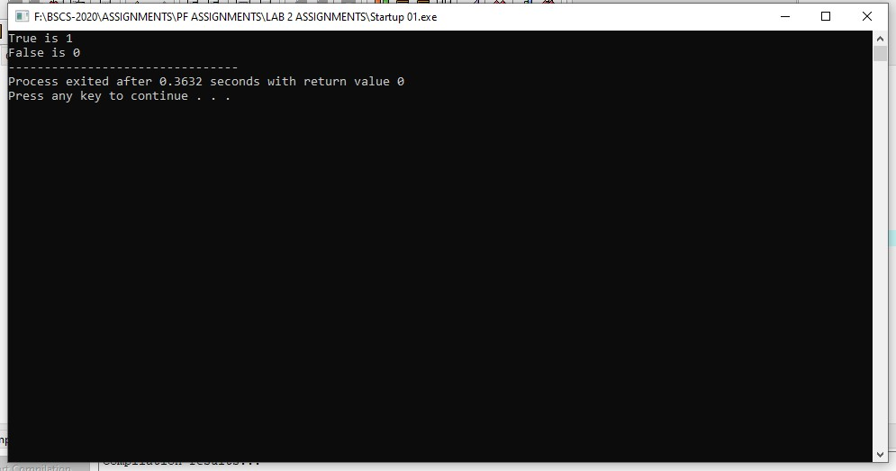

**Startup** # 02

#include <iostream>

using namespace std;

main(){

int x=5,y=10;

cout<<"X is "<<x<<" and Y is "<<y<<endl;

if (x>y);

cout<<"X is greater than y";

}

**CONCLUSION:**

//IF statement can continue working for the statement which is true

//and hide the statment which is false

//similarly in this case as we know 10 is greater then 5 but according to given condition

// it says us that 10 is less then 5 so thatwhy compiler can hide the beneath statement which is false

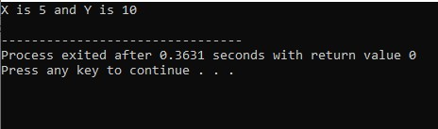

Compiler hides the red layer as this statement is false

There isn’t any effect on program by placing semi colon after if condition it can compile easily

**Startup #03**

#include <iostream>

using namespace std;

main(){

int x;

cout<<"Enter a number : ";

cin>>x;

if (x%2==0)

cout<<x<<" is even";

else

cout<<x<<" is odd";

}

**CONCLUSION**

//if we enter 40 or any of even number which is easily divided by 2 then program skip else condition and compile only if statement because we have declare even values in if condition and odd values in else statement

